Hi-Spec V3 Handbrake Caliper
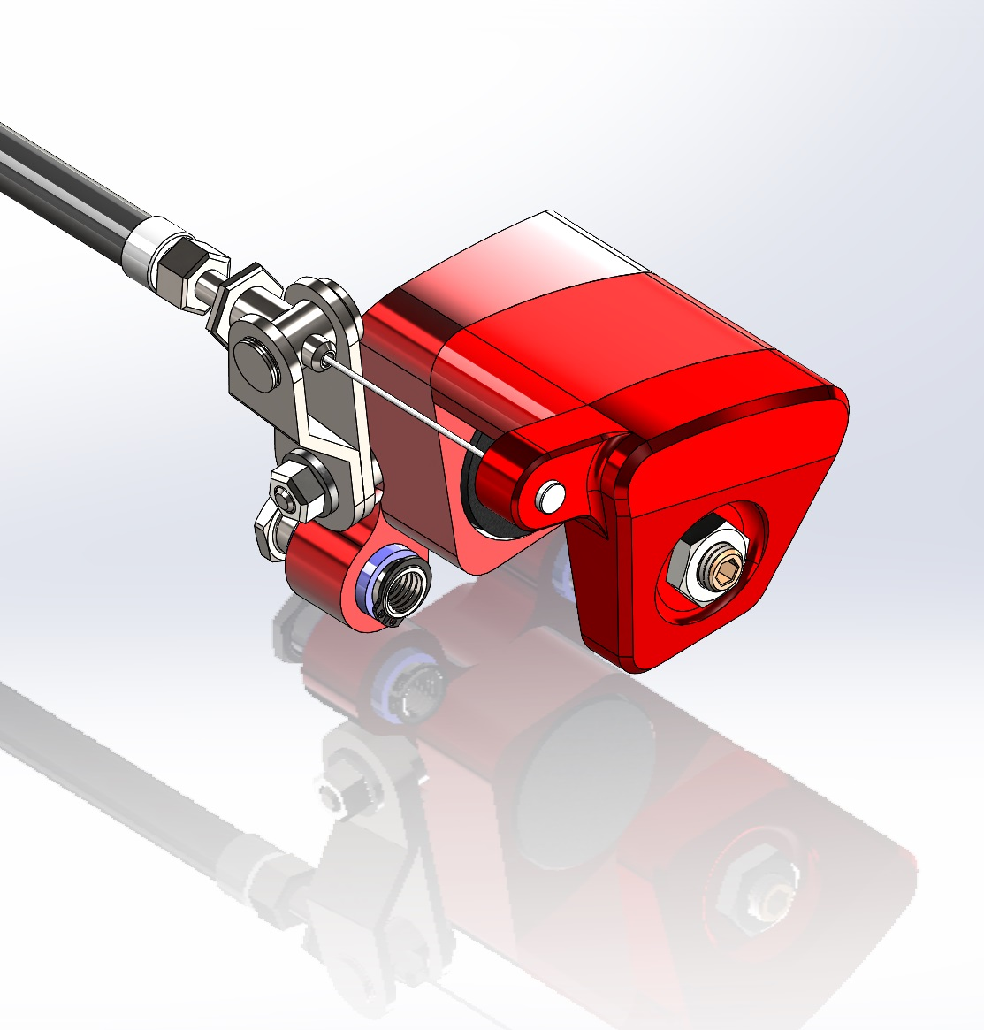Setting up the Hi-Spec V3 handbrake caliper is easy.
However without taking a couple of points into consideration performance could be greatly reduced.

Below is a picture of how the V3 Spot should look when everything is new.
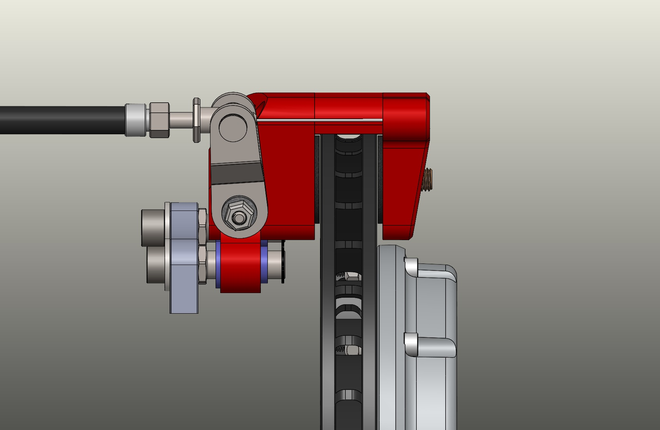
Next, just for clarity, the main parts are labelled:-
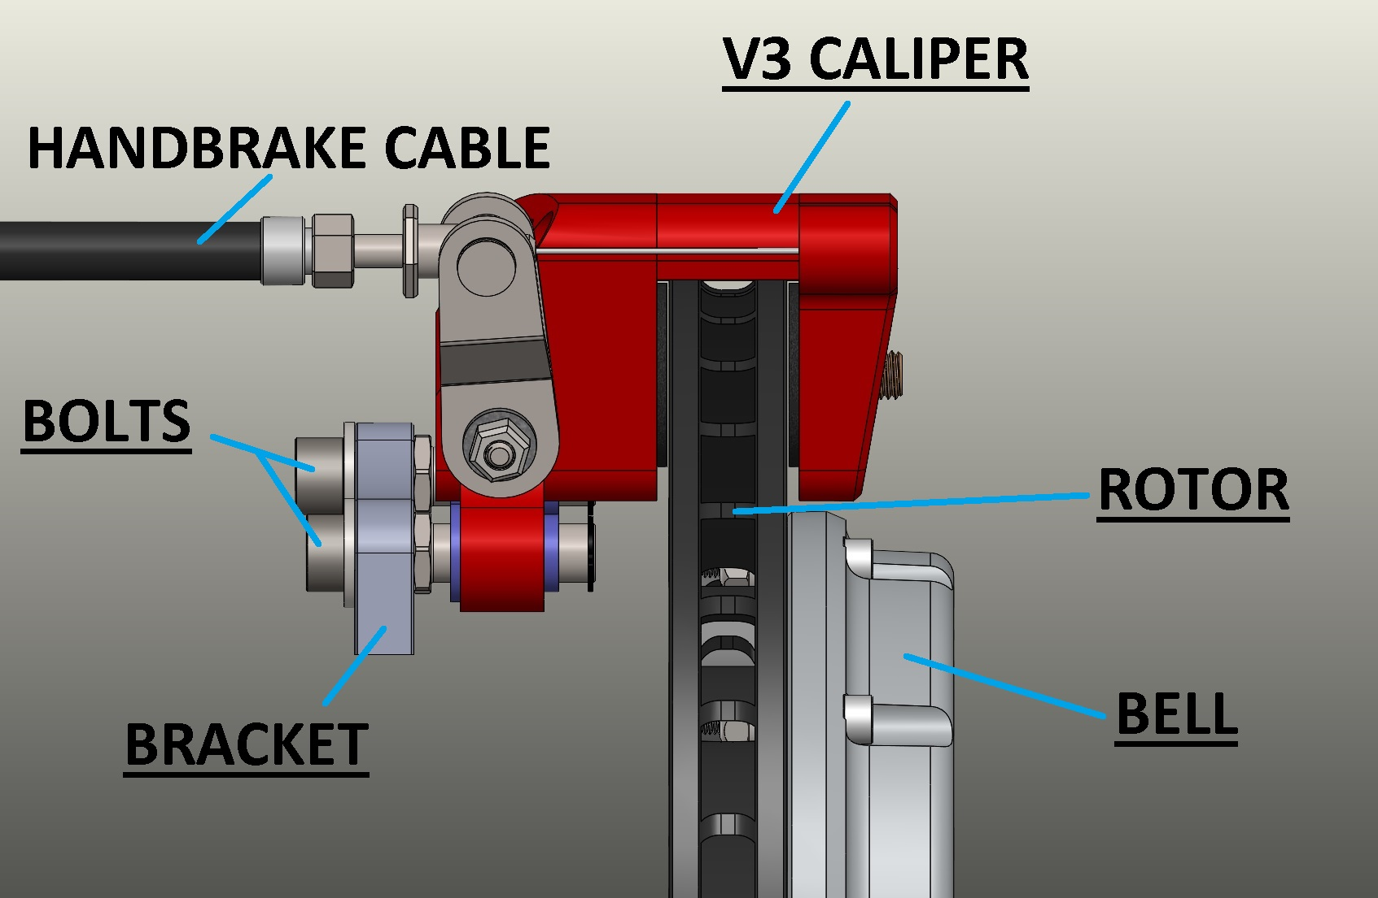
Pay attention to the size of the gap on each side of the slider pin.
On new kits you should be aiming for either a neutral gap (the same both sides) or slightly offset, so a little bigger on the disc side.
To make sure that you are not getting a false reading it is best to do this with the handbrake cable completely removed.
You will therefore have the arms fully back in their home position & use the “PAD ADJUSTER” on the front to take out any free play. (You need a 5mm Allen key to adjust)
Hi-Spec recommends tightening the pad adjuster until tight and then backing off one half of a turn to give ideal clearance.
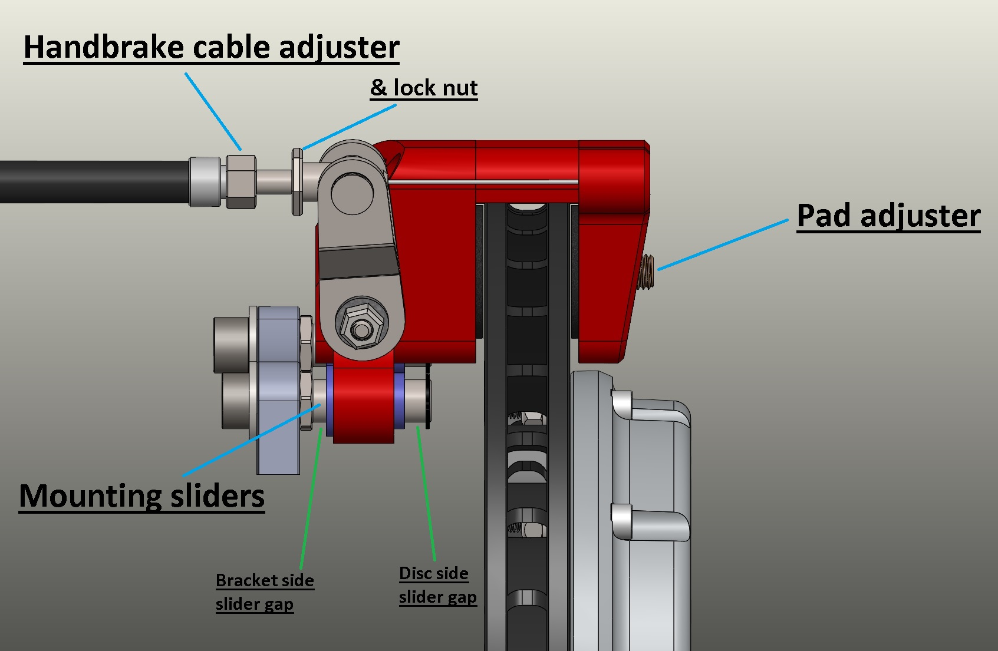
Once the caliper spacing is perfect you can check to ensure the bracket is in the correct position & therefore the slide pin spacing is correct.
The bracket can be shimmed if necessary.

Once you are happy with this stage you can attach the handbrake cable.
Use the “HANDBRAKE CABLE ADJUSTER” & “LOCK NUT” to remove any slack from the cable and test that the handbrake lever feels ok. Normally 3 “clicks” is perfect. 5 or more means more work to be done!
It’s important not to over tighten anything. This may cause the pads to “drag” and increase the pad wear.

As the pads start to wear, the handbrake cable will have to pull the lever further & further.
The mechanism is designed to work most effectively when the arm is close to the start point. That is “ON CAM”
As it wears it will go “OVER CAM” and lose a little efficiency. If you notice the performance dropping off it is a sure sign that it is time for a little adjustment.
Always use the “PAD ADJUSTER” on the front face of the caliper for adjustment.
When everything is quite badly worn, then you may need to use the “HANDBRAKE CABLE ADJUSTER” as the last resort to gain a little more life, before replacing pads & rotors.

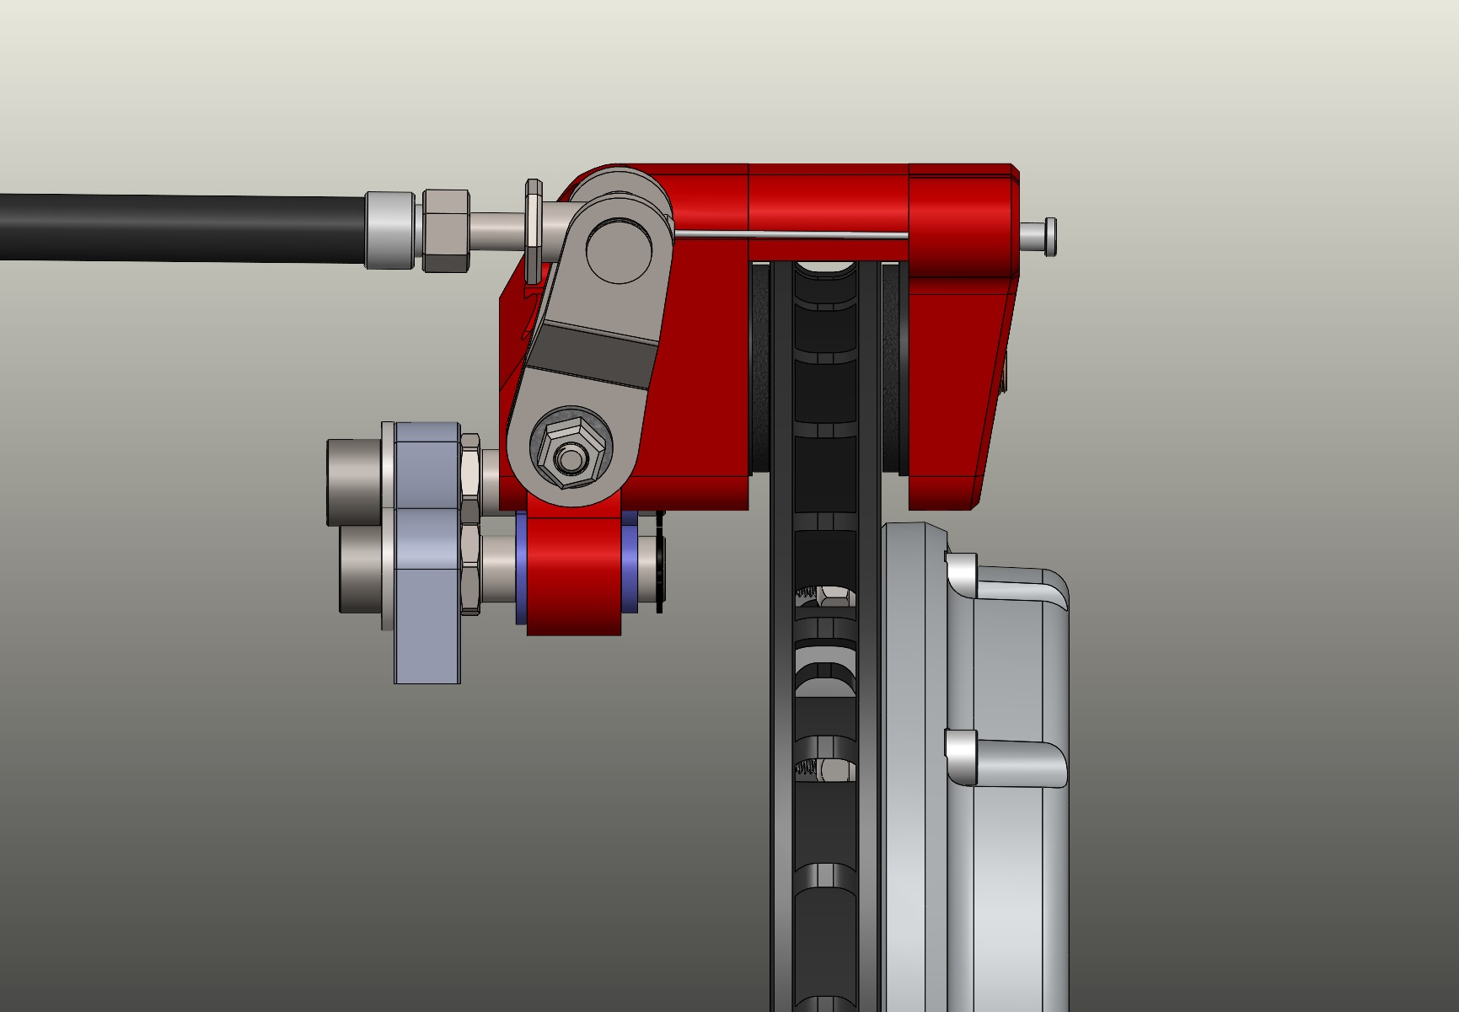
Above you can see the disc is badly worn, the pads are worn & the “PAD ADJUSTER” is wound in, also the lever is quite far forward.
If you look at the gaps on the “MOUNTING SLIDER” now, you can see the caliper has travelled forwards a bit, and the gap is now bigger on the bracket side.
This is all the travel you should expect to see.

If your kit was badly set up and the caliper was to run to the limit of the slider it would be unable to function correctly.
You would get much reduced performance.
Also it could be applying very one sided loads to the disc rotor and this could dangerously damage the structure of the disc.

